***Enterococcus* assay protocol**

**Field Collections**

Materials:

● Medium size cooler

● Ice

● 500ml sample bottle

● Labeling tape

● Pencils

Procedure:

● Submerge 500ml sample bottles until they are completely full. Make sure to sample from about 10cm below the surface. Try not to collect any sediment or other organic material.

● Cap bottles and label with pencil on label tape

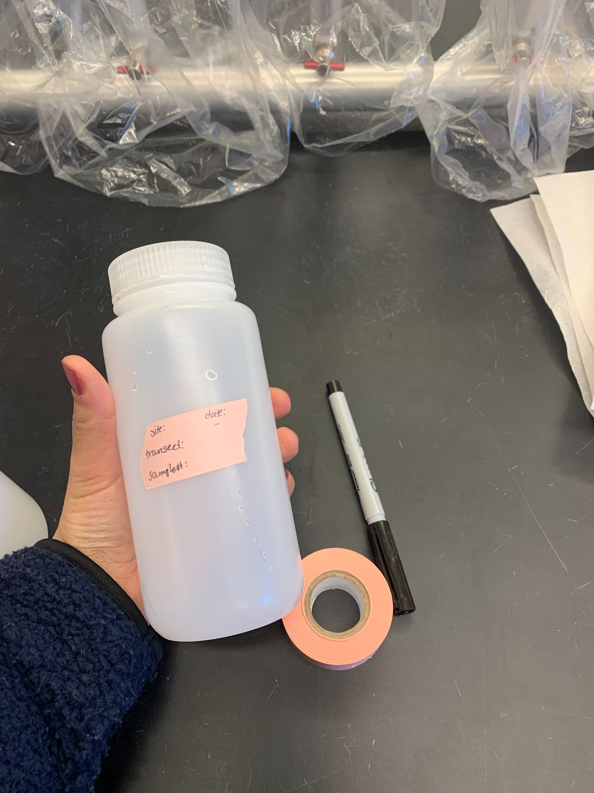

● Place it in the cooler with ice. Try to limit the bottles exposure to sun as the UV radiation can decrease the *Enterococcus* In the sample.

● Samples should be on ice for a maximum time of 6 hours before being filtered and plated.

**Making *Enterococcus* agar plates**

Materials

● m-*Enterococcus* agar medium

● petri dishes

● gloves

● hot plate

● stir bar

● 1000ml erlenmeyer flask

● weigh boat

● scale

● DI water

Procedure

● add flask with 1000ml of DI water to the hot plate with a stir bar

● weigh 42g of medium in a weigh boat on a scale

● Suspend 42g medium in 1000ml of DI water

● Heat to boiling to dissolve completely

● lay out petri dishes on sterilized counter with lids off

● Pour into petri dishes and allow medium to solidify

● As they dry put lid halfway on plate

● After petri dishes have solidified invert and place in the fridge for up to 2 weeks

**Lab filtration and plating**

Materials:

● Filter pump (ex. Millepore Sterifil, EMD Millepore, MA, USA)

● Gloves

● Squirt bottle with Deionized (DI) water

● cellulose ester GN-6 Metricel® gridded and sterile 47 mm membrane filters (1 per sampling spot)

● Tweezers

● Plates with set agar medium

● Incubator

● ethanol

● 10% bleach

● Lighter/bunsen burner

● Sharpie

Procedure:

● Set up sterile aseptic filter system and rinse with DI water

● Bring water samples to bench/table

● Put on gloves

● Sterilize tweezers by dipping in 10% bleach -> DI water -> ethanol -> flame

● Remove a new filter and place on pump with tweezers. Put top of pump over filter and pour 100ml one sampling spot into the pump. Turn on pump and filter sample. Spray down side of pump with DI water to wash off excess *Enterococcus* and turn off the pump.

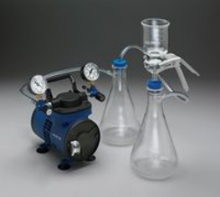

● Open the pump and plate the filter on sterile Slanetz and Bartley selective medium with the tweezers.

● Cover the plate with its top and label the plate with a sharpie

● Make sure to spray down the pump with DI water and sterilize the tweezers between each sample

● Afterwards immediately incubate plates at 37.0 ± 1.0 °C for 4.0 ± 0.5 hours followed by 44.0 ± 0.5 °C for 40 ± 4 hours

● Count the colony forming units on the plate after incubation and record.